**Automatic Number Plate Recognition with IBM Cloud**

1. **INTRODUCTION**
   1. Overview:

Number Plate Recognition System is an image processing technology which uses number (license) plate to identify the vehicle. The objective is to build a web application that can efficient automatic authorized vehicle identification system by using the vehicle number plate. Number plate recognition (NPR) can be used in various fields such as vehicle tracking, traffic monitoring, automatic payment of tolls on highways or bridges, surveillance systems, tolls collection points, and parking management systems.

* 1. Purpose:

The escalating increase of contemporary urban and national road networks over the last decades emerged the need for efficient monitoring and management of road traffic. Meanwhile, rising vehicle use causes social problems such as accidents, traffic congestion, and consequent traffic pollution. Number Plate Recognition is a process where vehicles are identified or recognized using their number plate or license plate. NPR uses image processing techniques so as to extract the vehicle number plate from digital images.

1. **Literature Survey**
   1. Existing Problem:

* Present Existing models are made integrating with hardware input devices and are only suitably used by people with those hardware devices like camera, illuminator, frame grabber, etc.,
* Existing models also uses multiple images of the same car and applies several computations on it to detect the number plate making it bit slow.
  1. Proposed solution:
* We are proposing a model which takes single url of a car image and detects its number plate using rapidAPI, thereby making it usable by anyone.
* As the input is easily generated by anyone, we are getting rid of the hardware dependencies.
* Also it is developer friendly to implement any future requirements and features.

1. **Theoretical Analysis**
   1. Block Diagram:

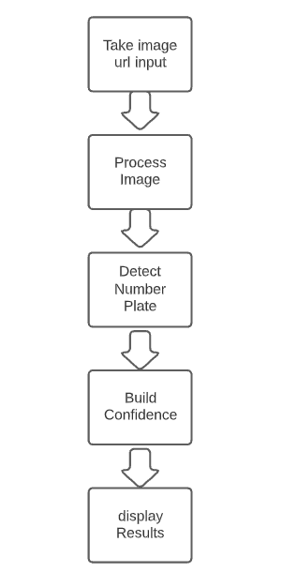

* 1. Hardware / Software Designing:

**Software Requirements:**

* OS – Windows XP,7,8,10
* Jupyter Software
* Spyder Software
* Anaconda Command Prompt

**Hardware Components:**

* Processor – i3
* Hard Disk Storage – 10 GB
* RAM – 1GB

1. **Flowchart:**

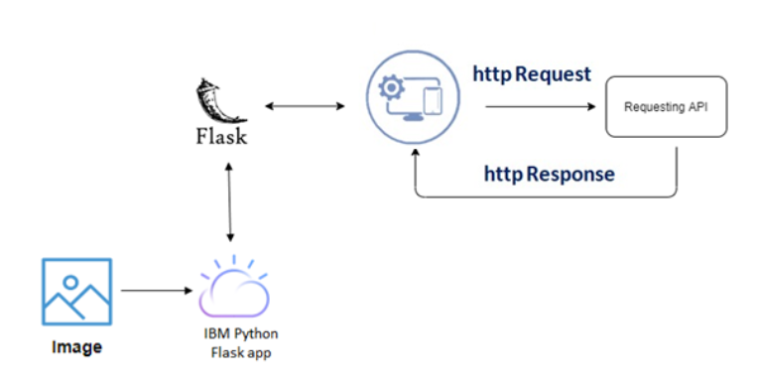

1. **Experimental Investigations:**

The main objective of this research is to investigate the accuracy and effectiveness of detecting the number plates of cars using rapid API. Upon giving the different car images in different orientations as input, the model is supposed to deliver the detected the number plate of respective car along with the confidence with which it assures the recognition.

1. **Result:**

After conducting so many attempts and usage on different systems by different users it is observed that, the model works with a latency of 866ms and confidence of 80% on average.

1. **Advantages & Disadvantages:**
   1. Advantages:

* Maintaining better traffic environment
* Anyone can use this software.
* Easy to use.
* No hardware dependencies.
* Flexible for updates.
* Faster and simple than existing models.
  1. Disadvantages:
* Sometimes model may provide incorrect number plate of car
* User needs to feed one by one input to the system.
* Presently equipped with minimum features.

1. **Applications:**

* Vehicle tracking by government Authorities.
* Traffic monitoring by traffic police.
* Parking management.
* Automatic payments at highway tolls.

1. **Conclusions:**

* In this system we developed AUTOMATIC NUMBER PPLATE DETECTION model which takes one url of an car image and displays the car number plate along with the confidence.
* It is quite clear that ANPR is presently not possible to achieve 100% overall accuracy because of certain factors like different illumination conditions, vehicle shadow and non-uniform size of license plate characters, different font and background color affect the performance of ANPR.
* Implementation of this model is quite useful for many people in regards of various aspects.

1. **Future Scope:**

* This model being the application of Artificial intelligence, has better scope in the feature
* In the future, more technological developments might be possible in the system with additional features.
* Advancement of technology might help this system to improve its accuracy and reach perfection.

1. **Bibliography :**
2. You-Shyang Chen and Ching-Hsue Cheng, "A Delphibased rough sets fusion model for extracting payment rules of vehicle license tax in the government sector," Expert Systems with Applications, vol. 37, no. 3, pp. 2161- 2174, 2010.
3. Anton Satria Prabuwono and Ariff Idris, "A Study of Car Park Control System Using Optical Character Recognition ," in International Conference on Computer and Electrical Engineering, 2008, pp. 866-870.
4. A Albiol, L Sanchis, and J.M Mossi, "Detection of Parked Vehicles Using Spatiotemporal Maps," IEEE Transactions on Intelligent Transportation Systems, vol. 12, no. 4, pp. 1277-1291, 2011.
5. Christos Nikolaos E. Anagnostopoulos, Ioannis E. Anagnostopoulos, Ioannis D. Psoroulas, Vassili Loumos, and Eleftherios Kayafas, License Plate Recognition From Still Images and Video Sequences: A Survey, vol. 9, no. 3, pp. 377-391, 2008.
6. Christos Nikolaos E. Anagnostopoulos, Ioannis E. Anagnostopoulos, Vassili Loumos, and Eleftherios Kayafas, "A License Plate-Recognition Algorithm for Intelligent Transportation System Applications," pp. 3
7. H. Erdinc Kocer and K. Kursat Cevik, "Artificial neural netwokrs based vehicle license plate recognition," Procedia Computer Science, vol. 3, pp. 1033-1037, 2011.
8. . [7] A Roy and D.P Ghoshal, "Number Plate Recognition for use in different countries using an improved segmenation," in 2nd National Conference on Emerging Trends and Applications in Computer Science(NCETACS), 2011, pp. 1-5. [8]
9. Kaushik Deb, Ibrahim Kahn, Anik Saha, and Kang-Hyun Jo, "An Efficeint Method of Vehicle License Plate Recognition Based on Sliding Concentric Windows and Artificial Neural Network," Procedia Technology, vol. 4, pp. 812-819, 2012. [9]
10. Lucjan Janowski et al., "Quality assessment for a visual and automatic license plate recognition," Multimedia Tools and Applications Springer US, pp. 1-18, 2012. [10]
11. Yifan Zhu, Han Huang, Zhenyu Xu, Yiyu He, and Shiqiu Liu, "Chinese-style Plate Recognition Based on Artificaial Neural Network and Statistics," Procedia Engineering, vol. 15, pp. 3556-3561, 2011.
12. **Appendix**
    1. Source code:

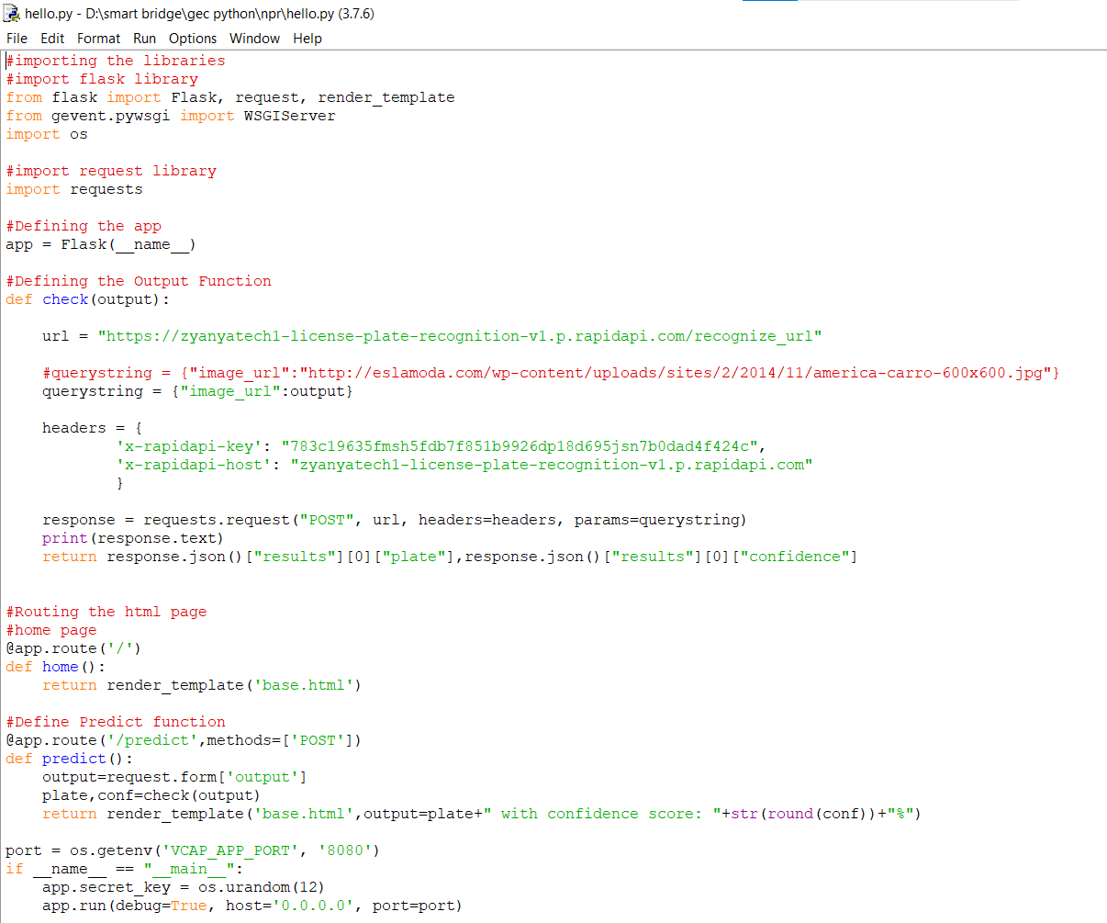

* 1. UI Output Screenshot:

Image :



Image url: <https://i.imgur.com/bHYB9Ab.jpg>

UI output:

